**Project Report**

**On**

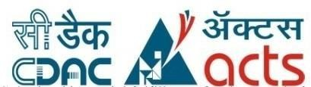**IoT Enabled e-Farming and Monitoring System**

*Submitted*

*In partial fulfillment*

*For the award of the Degree of*

**PG-Diploma in Internet of Things**

**(C-DAC, ACTS (Pune))**

**Guided By: Submitted By:**

Mr. Shubham Srivastava 1. Aniket Rajigare (230940126002)

2. Nandan A (230940126008)

3. Ritesh Nagesh Nagare (230940126011)

4. Shreyash Sarage (230940126014)

5.Siddhesh Nandurkar (230940126016)

**Centre for Development of Advanced Computing (C-DAC, ACTS Pune- 411008)**

## Acknowledgement

This is to acknowledge our indebtedness to our Project Guide, **Mr. Shubham Srivastava**,C-DAC ACTS, Pune for her constant guidance and helpful suggestion for preparing this project. **IoT Enabled e-Farming and Monitoring System** We express our deep gratitude towards her for inspiration, personal involvement, constructive criticism that she provided us along with technical guidance during the course of this project.

We take this opportunity to thank **Mr. Gaur Sunder** (Associate Director, Head of Department, CDAC) for providing us such a great infrastructure and environment for our overall development.

We express sincere thanks to **Ms. Namrata Ailawar** (Joint Director, Process Owner, CDAC) for their kind cooperation and extendible support towards the completion of our project.

It is our great pleasure in expressing sincere and deep gratitude towards **Ms. Risha P.R** (Associate Director, Program Head, CDAC) and **Ms. Pratiksha Gacche** (Course Coordinator, PG-DIoT) for their valuable guidance and constant support throughout this work and help to pursue additional studies.

Also, our warm thanks to C-DAC ACTS Pune, which provided us this opportunity to carry out, this prestigious Project and enhance our learning in various technical fields.

**Aniket Rajigare (230940126002)**

**Nandan A (230940126008)**

**Ritesh Nagesh Nagare (230940126011)**

**Shreyash Sarage (230940126014)**

**Siddhesh Nandurkar (230940126016)**

## ABSTRACT

Developing IoT-enabled e-farming and monitoring systems to enhance agricultural efficiency. The project involves integrating sensors for Real-time Data collection, Implementing automated irrigation based on soil moisture levels, and creating a user-friendly interface for farmers to monitor and control the farming environment remotely.

An IoT-enabled e-farming and monitoring system is a technology-based solution that uses Internet of Things (IoT) devices, such as sensors, actuators, and computing systems, to monitor and manage agricultural operations remotely. This system can automate various farming activities, such as irrigation, fertilization, and pest control, by collecting data from the field, analyzing it, and making informed decisions based on the insights gained.

To develop an IoT-enabled e-farming and monitoring system for terrace farming, one can follow the general architecture of IoT-based smart farming systems, which includes sensors, gateways and database. The sensors can be used to measure various environmental parameters, such as temperature, humidity and soil moisture. The gateways can be used to collect and transmit data from the sensors to the database, where they can be analyzed and visualized.

**Table of Contents**

|  |  |  |
| --- | --- | --- |
| **S. No** | **Title** | **Page No.** |
|  | **Front Page Acknowledgement Abstract**  **Table of Contents** | **I II III**  **IV** |
| **1**  **1.1**  **1.2** | **INTRODUCTION**  Introduction  Objective and Specifications | **1-2** |
| **2** | **LITERATURE REVIEW** | **3** |
| **3** | **METHODOLOGY/ TECHNIQUES** |  |
| **3.1** | Work Flow Phase | **4** |
| **4** | **REQUIREMENT** |  |
| **4.1** | Hardware Requirement | **5** |
| **4.2** | Software Requirement | **5** |
| **5** | **BLOCK DIAGRAM AND WORKING** |  |
| **5.1** | Block Diagram | **7** |
| **5.2** | Working | **7-8** |
| **6** | **COMPONENTS** | **9-10** |
| **7** | **RESULTS** | **11-14** |
| **8** | **CONCLUSION** |  |
| **8.1** | Conclusion | **15** |
| **8.2** | Future Enhancement | **15** |
| **9** | **REFERENCES** | **16** |

**CHAPTER 1**

.

**INTRODUCTION**

The Internet of Things (IoT) is a rapidly growing technology that is transforming various industries, including agriculture. IoT-enabled e-farming and monitoring systems are smart farming solutions that leverage IoT technology to automate and optimize farming operations. These systems consist of sensors, gateways, and database that enable real-time monitoring and control of various environmental parameters, such as temperature, humidity and soil moisture.

Terrace farming is a traditional farming practice that has been used for centuries in hilly and mountainous regions to maximize the use of limited arable land. However, terrace farming faces several challenges, such as limited access to water and nutrients, varying environmental conditions, and the need for manual labor. IoT-enabled e-farming and monitoring systems can help address these challenges by providing real-time monitoring and control of various environmental parameters, such as soil moisture and temperature.

In summary, IoT-enabled e-farming and monitoring systems for terrace farming can offer several benefits, such as increased crop yield, reduced resource consumption, and improved operational efficiency.

**1.1 Objective**

* **Real-time monitoring of environmental parameters:** An IoT-enabled e-farming and monitoring system can provide real-time monitoring of environmental parameters, such as soil moisture, temperature and humidity to help farmers make informed decisions about irrigation and other farming operations.
* **Optimization of resource usage:** By using sensors to monitor environmental parameters and crop growth, an IoT-enabled e-farming and monitoring system can help optimize the use of resources, such as water and energy, leading to cost savings and a reduced environmental impact.
* **Increased crop yield and quality:** An IoT-enabled e-farming and monitoring system can help increase crop yield and quality by providing real-time data on crop growth and environmental conditions, enabling farmers to optimize farming operations and take corrective actions when necessary
* **Remote monitoring and control:** An IoT-enabled e-farming and monitoring system can enable remote monitoring and control of various farming operations, allowing farmers to manage their farms from anywhere, at any time.
* **Improved operational efficiency:** An IoT-enabled e-farming and monitoring system can help improve operational efficiency by automating various farming operations, reducing the need for manual labor, and providing real-time data for decision-making.
* **Data analysis and prediction:** An IoT-enabled e-farming and monitoring system can collect and analyze data from sensors and other sources to predict future trends and provide insights for decision-making, such as predicting weather patterns, crop growth, and disease outbreaks.
* **Scalability and flexibility:** An IoT-enabled e-farming and monitoring system can be designed to be scalable and flexible, allowing farmers to add or remove sensors and actuators as needed, and to adapt to changing farming conditions and requirements

**CHAPTER 2**

**LITERATURE REVIEW**

The review highlights the potential of IoT-enabled e-farming and monitoring systems to address various challenges in agriculture, such as the need for efficient resource management, climate change, and labor shortages. The authors identify the most common IoT devices used in agriculture, including sensors and gateways, and the various communication protocols used for data transmission.

The review also discusses the different layers of IoT-based agricultural systems, including the perception layer, network layer, and application layer. The perception layer consists of sensors that collect data from the environment, while the network layer is responsible for data transmission and communication. The application layer provides various services, such as data analysis, decision-making, and automation.

Furthermore, the review discusses various IoT-based agricultural applications, such as precision agriculture, livestock monitoring, and smart irrigation systems. The authors also highlight the benefits of IoT-enabled e-farming and monitoring systems, such as increased crop yield, reduced resource consumption, and improved farm management.

Overall, this literature review provides a comprehensive overview of the role of IoT technology in agriculture and highlights the potential of IoT-enabled e-farming and monitoring systems for improving farm management and productivity.

**CHAPTER 3**

**METHODOLOGY AND TECHNIQUES**

**3.1 Work Flow Phase -**

* **Sensor and Data Collection:**
  + Deploy sensors (temperature, humidty, soil moisture, etc.) to gather real-time data from the farm.
  + Utilize IoT devices to transmit collected data to a centralized system.
* **Communication Protocols:**
  + Implement communication protocols (e.g., MQTT) for efficient data-transfer between IoT devices and the central server.
* **Cloud Computing:**
  + Utilize cloud platforms for data storage, processing, and analysis, enabling scalable and reliable solutions.

**Data Analytics:**

Employ data analytics techniques to derive insights from the collected data, aiding in decision-making for farmers

**Automation and Control:**

Integrate actuators and automation systems to remotely control irrigation, fertilization, and other processes based on the analyzed data.

**Mobile and Web Applications:**

Develop user-friendly interfaces, such as mobile apps or web portals, to allow farmers to monitor and control farm activities from anywhere.

**Security Measures:**

Implement robust security measures to protect the system from unauthorized access and ensure the integrity of farm data.

**Energy Efficiency:**

Optimize energy consumption by IoT devices through efficient protocols and hardware to ensure sustainable and cost-effective operation.

**Scalability and Interoperability:**

Design the system to be scalable to accommodate the growing needs of the farm and ensure interoperability with different IoT devices and platforms.

**User Training and Support:**

Provide training and support to farmers for effective utilization of the system, fostering adoption and maximizing its benefits.

**CHAPTER 4**

**REQUIREMENT**

**4.1 Hardware Requirement: -**

1) Raspberry Pi  
2) DHT22  
3) ESP32  
4) A to D Converter  
5) Breadboard  
6) Capacitive Soil Moisture Sensor  
7) Relay

**4.2 Software Requirement:-**

1) Arduino ide Software  
2) Embedded C Language

3) Database : MySQL

4) Backend: PHP, NodeJS

5) Frontend: HTML, CSS

**CHAPTER 5**

**BLOCK DIAGRAM AND WORKING**

**5.1 Block Diagram:-**

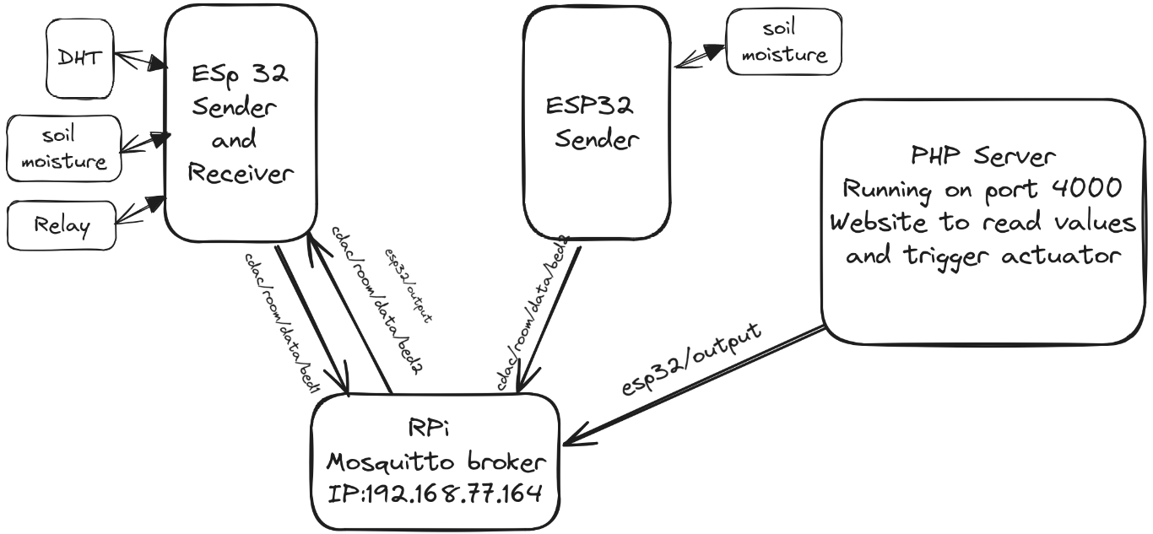

**5.2 Working**

**Hardware Integration:**

Collaborate on integrating various sensors into the farming infrastructure, ensuring seamless data collection and control.

**Software Development:**

Contribute to developing the software backend, utilizing cloud computing for data storage, analytics, and processing.

**Communication Protocols:**

Implement and optimize communication protocols to facilitate efficient data exchange between devices and the central system.

**User Interface Design:**

Work on creating user-friendly interfaces for mobile and web applications, allowing farmers to interact with and manage the system effortlessly.

**Security Measures:**

Play a role in implementing robust security features to protect the system and the sensitive data it handles. Testing and Quality Assurance:

**CHAPTER 6**

**COMPONENTS**

1. **ESP32 sensor:-**

ESP32 is a series of low-cost, low-power [system on a chip](https://en.wikipedia.org/wiki/System_on_a_chip) [microcontrollers](https://en.wikipedia.org/wiki/Microcontroller) with integrated [Wi-Fi](https://en.wikipedia.org/wiki/Wi-Fi) and dual-mode Bluetooth.

ESP32 is a single 2.4 GHz Wi-Fi-and-Bluetooth combo chip designed with the TSMC low-power 40 nm technology.

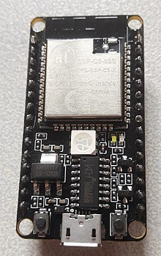

1. **DHT22 :-**

DHT22 output calibrated digital signal. It utilizes exclusive digital-signal-collecting-technique and humidity sensing technology, assuring its reliability and stability.Its sensing elements is connected with 8-bit single-chip computer.

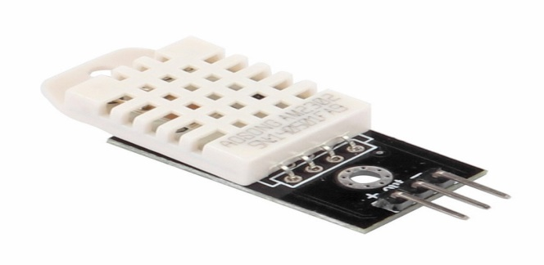

1. **Capacitive Soil Moisture Sensor:-**

This**Capacitive soil moisture** sensor measures soil moisture levels by capacitive sensing rather than resistive sensing like other sensors on the market. It is made of corrosion-resistant material which gives it excellent service life. Insert it into the soil around your plants and impress your friends with real-time soil moisture data!

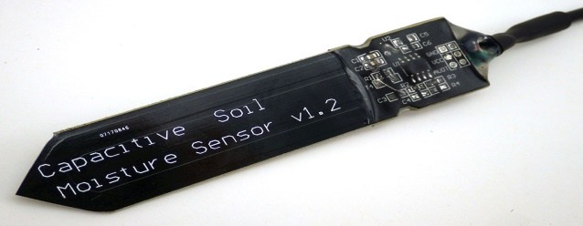

1. **Analog to Digital Converter :-**

A converter that is used to change the analog signal to digital is known as an analog to digital converter or ADC converter.

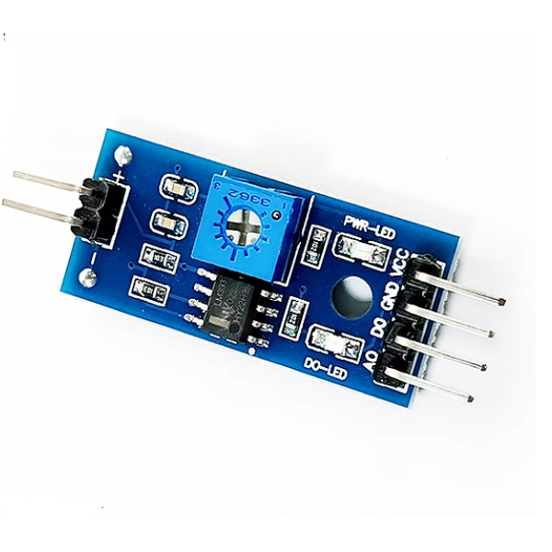

1. **Raspberry Pi :-**

The Raspberry Pi is a debit card-sized low-cost computer that connects to a computer Desktop or TV and uses a standard mouse and Keyboard. It has a dedicated processor, Memory and a graphics driver, just like a PC. It also comes with its operating system, Raspberry Pi OS, a modified version of Linux.

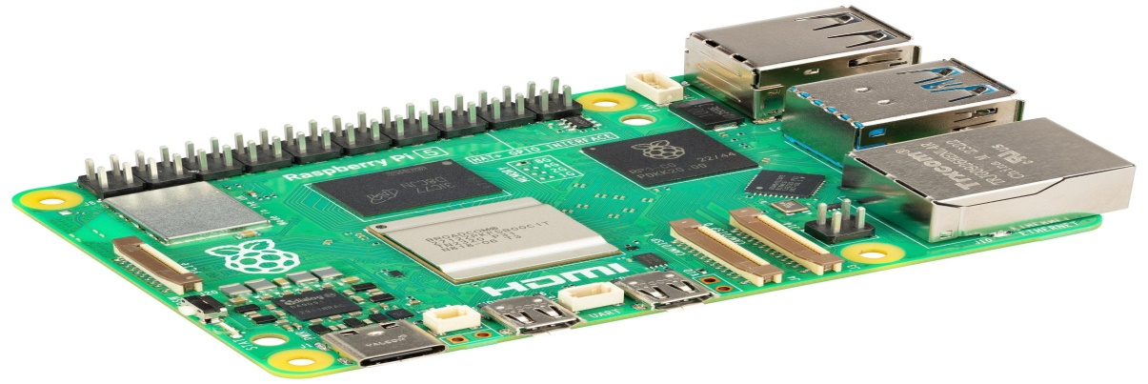

1. **Relay :-**

A Relay is a simple electromechanical switch. While we use normal switches to close or open a circuit manually, a [Relay](https://www.electronicshub.org/relay-wiring-diagram/) is also a switch that connects or disconnects two circuits. But instead of a manual operation, a relay uses an electrical signal to control an electromagnet, which in turn connects or disconnects another circuit.

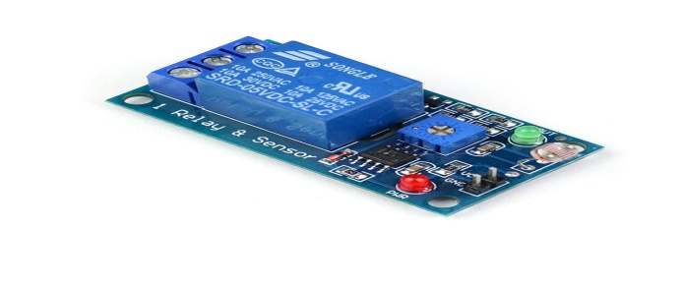

**CHAPTER 7**

**RESULTS**

1. **LOGIN_PAGE**

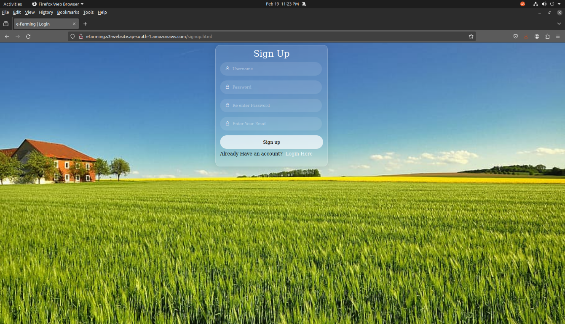

1. **HOME PAGE**

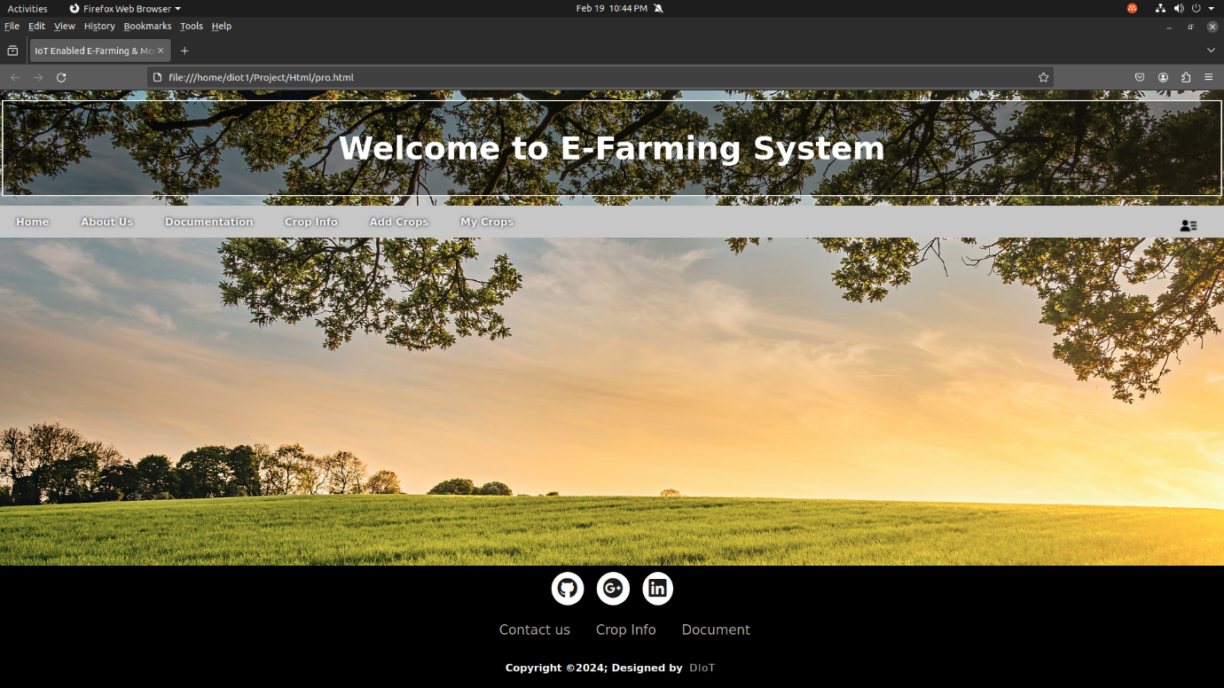

1. **CROP INFO**

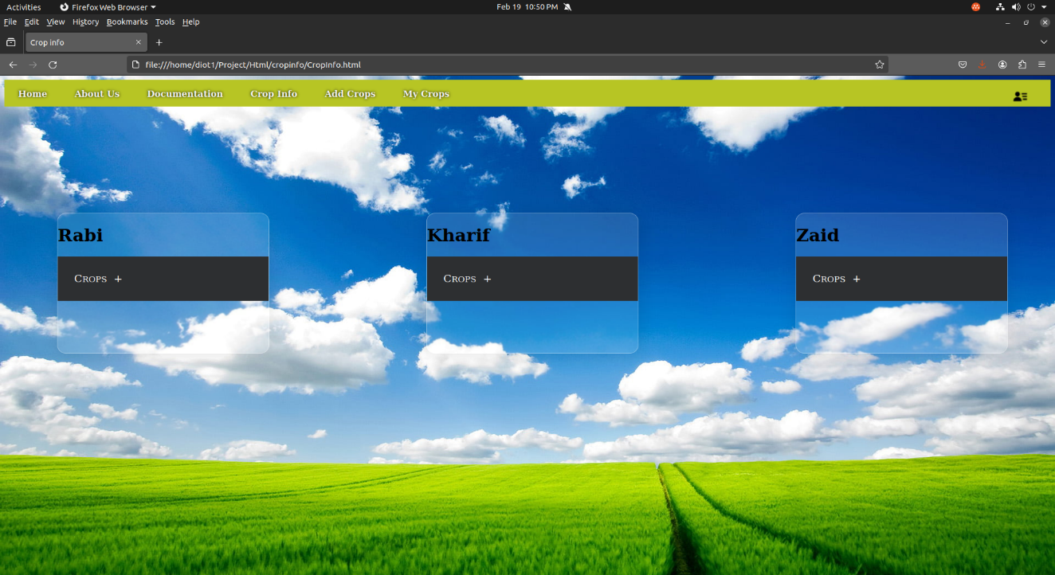

1. **ADD CROP**

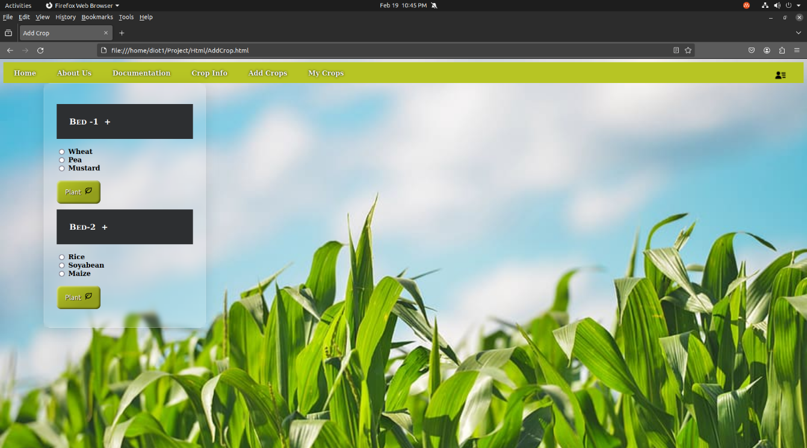

1. **VISUALISATION**

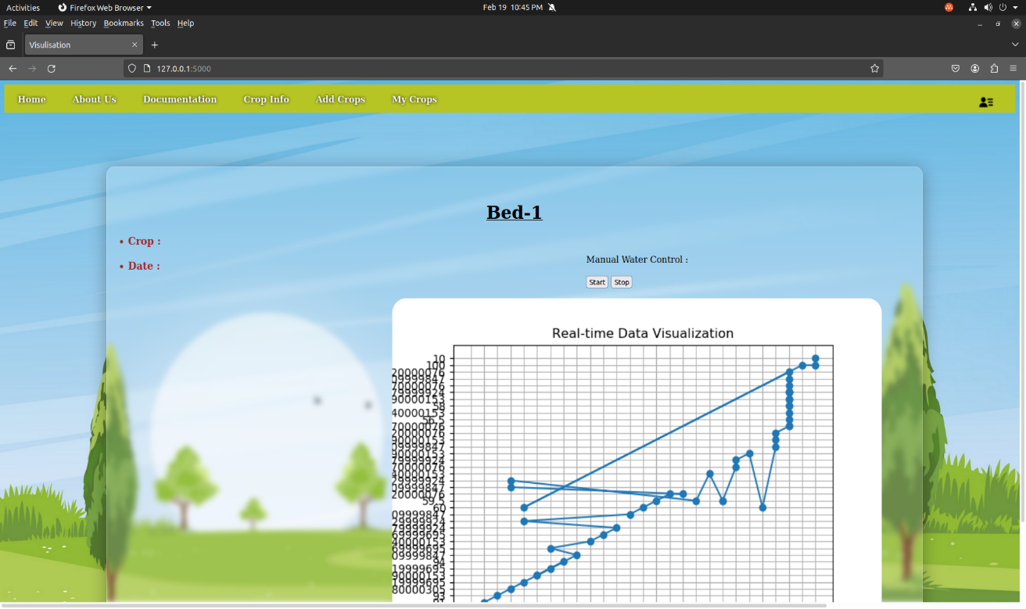

1. **SERIAL MONITOR(Arduino)**

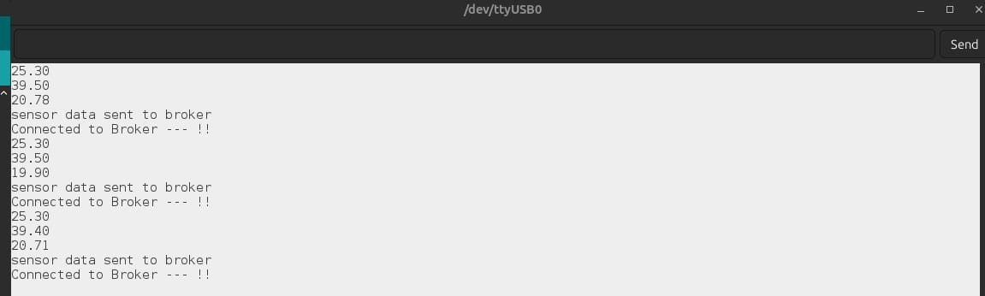

1. **HARDWARE CONNECTION**

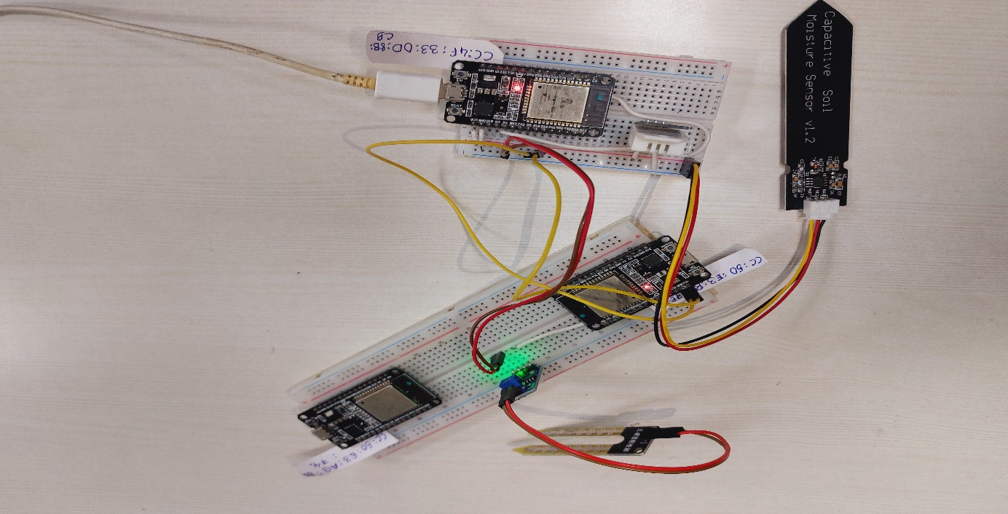

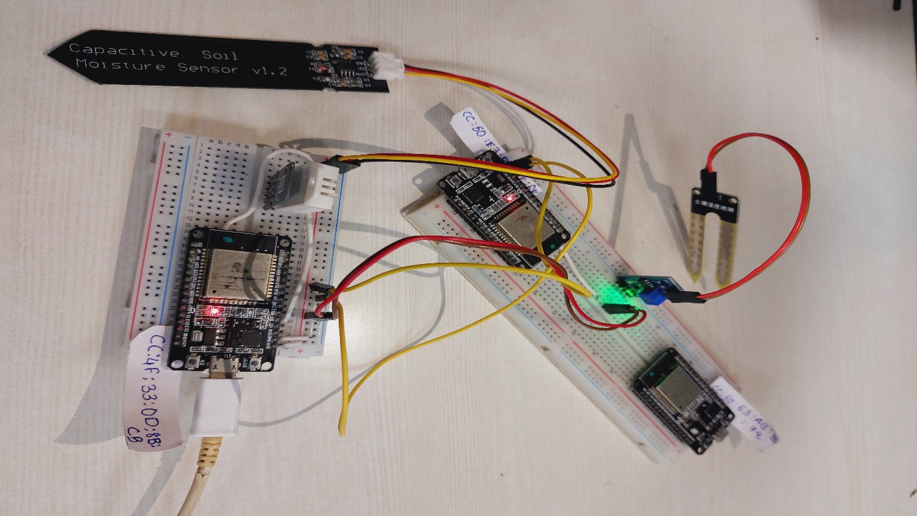

**CHAPTER 8**

**CONCLUSION**

**8.1 Conclusion**

In conclusion, the IoT Enabled E-Farming and Monitoring System stands at the intersection of cutting-edge technologies and agricultural practices, promising transformative benefits for farmers. By seamlessly integrating sensors, communication protocols, the system enables real-time data collection, analysis, and remote control, empowering farmers with actionable insights and efficient resource management. As we advance in hardware, software, and user interface design, ensuring security, scalability, and sustainability remains pivotal. Collaborative efforts, user training, and continuous innovation will play key roles in realizing the full potential of the technology, ultimately fostering a more resilient and productive future for agricultural.

* 1. **Future Enhancement**

1. **Integration with smart devices**: The system can be integrated with smart devices, such as smartphones and tablets, to enable remote monitoring and control of farming operations. This will enable farmers to manage their farms from anywhere, at any time.
2. **Standardization**: The development of standards for IoT-enabled e-farming and monitoring systems can enable interoperability and compatibility between different systems and devices. This will make it easier for farmers to integrate the technology into their farming practices and benefit from its capabilities.

**CHAPTER 9**

**REFERENCES**

1. Dhanaraju, M.; Chenniappan, P.; Ramalingam, K.; Pazhanivelan, S.; Kaliaperumal, R. Smart Farming: Internet of Things (IoT)-Based Sustainable Agriculture. Agriculture 2022, 12, 1745.
2. Farooq, M.; Siddiqui, M.H.; Rehman, S.; Kim, J. IoT-Enabled Agricultural Monitoring System for Sustainable Farming. Sustainability 2021, 13, 3781.
3. Gupta, P.; Tyagi, V.K.; Gupta, R.; Sharma, A. IoT-Based Smart Agriculture System for Precision Farming: A Review. IEEE Access 2020, 8, 102743-102762.
4. Quy, V.K.; Hau, N.V.; Anh, D.V.; Quy, N.M.; Ban, N.T.; Lanza, S.; Randazzo, G.; Muzirafuti, A. IoT-Enabled Smart Agriculture: Architecture, Applications, and Challenges.Appl.Sci.2022,12,33.